Dean Riccio LED-Sign-Project 07/23/2021

**Part 0: Introduction:**

Have you ever wanted to make a light up sign of your name? This project will teach you how to go from the initial idea to a fully fleshed concept with a PCB prototype. The contents will be divided under several sections to help differentiate each part of the process that was involved. This includes the BOM, theory and application behind the circuitry involved, as well as a step-by-step guide on how to make your own sign!

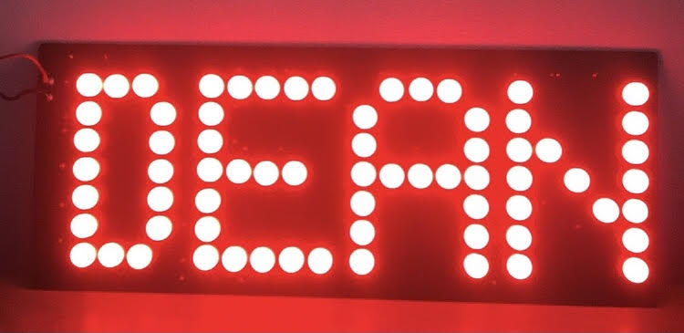

Before we start this project, it is important to note that having some experience using schematic software tools such as KiCad or Pspice along with building circuits on breadboards will make the process much smoother. However, if you haven’t done this before, this project is still beginner friendly, so I encourage you to try making your own sign and seeing how it goes.

**Part 1: Gathering Components:**

In terms of the components that are needed to make this project, it is relatively cheap and simple and consist of only a few parts. Before ordering anything, it’s important to get an idea of what you will be working with and seeing what vendors are suitable for the project. In terms of making an LED sign, a few things are evident in terms of what we would be using, LEDs of a particular size (the size is usually depicted in mm), resistors to limit the current draw from the power supply, and a breadboard to build our circuit on. This sign doesn’t necessarily have to be your name; however, this project has always been something I’ve wanted to do, and thought would be interesting. You can spell pretty much anything so long as you have enough LEDs to do so. To figure out the number of LEDs to spell out a letter, using any block letter image as reference can help determine how many LEDs to use per letter. The picture below shows the alphabet letters in block format.

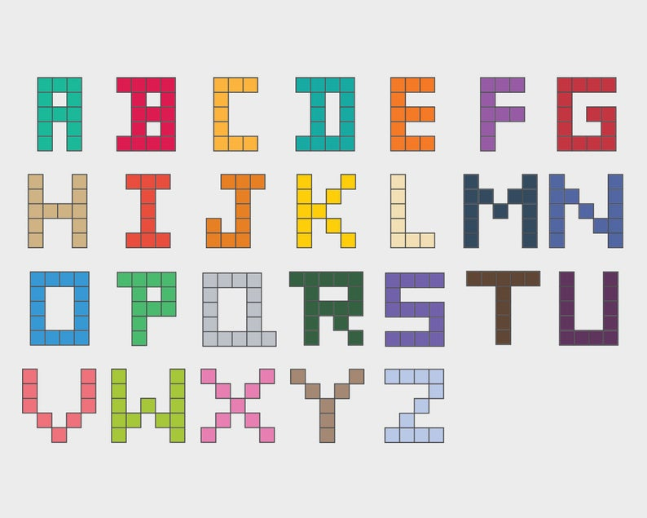

These letters can be expanded by adding blocks and can be adjusted to fit your size according. For the case of my name Dean, seeing as its four letters it’s a relatively short name. I decided to use 16 LEDs for the letter D, 18 for E and A, and 17 for D. Determining the size of the LEDs that you want to use can be quite tricky, seeing as pictures online can be quite deceiving. I decided to use 10mm LEDs, seeing as I wanted to keep the sign relatively on the small side but still make it larger than a typical LED. The color and size of the LED are insignificant in terms of importance of the project, what matters most is the resistance value that you chose to use for the LEDs. The picture below shows the dimensions of the 10mm LED I purchased from eBay.

We can decide what resistance to use through some basic calculations using ohms law. Depending on the power supply that is used and the maximum current that the LED can handle will determine what resistor value is best to use. I purchased a pack of 100 10mm LEDs from eBay for around $10 and according to the specifications on the listing the maximum forward current the LED can handle is 20mA. This is important because if this value is exceeded on the circuit the LED has a good chance of burning out and no longer being useable. You can check the forward voltage of the led on the continuity setting of your multimeter with the red probe on the anode and the black probe on the cathode.

With the maximum forward current of the LED in mind, we can choose a power supply that will be used for the circuit. Typically, anything in the 9-to-12-volt DC range will suffice, I decided to use a 9.83V DC wall wart power supply that plugs into an outlet (hence the name “wall wart”). The ratings labeled on the power supply was 7.5V DC with 1A of current but checking the value with two multimeters said otherwise. Therefore, its generally a good idea to check the voltage of a power supply with a multimeter before using it to finalize the exact voltage value you will be using for your project. With the voltage and current values known, we can now calculate the resistance needed for the circuit to work without burning the LEDS. Using ohm’s law, V=IR, we can manipulate the equation to solve for R resulting in R=V/I=9.83V/0.02A=491.5ohm. This means that 491.5ohms is the minimum resistance needed for the circuit to work without burning the LEDs.

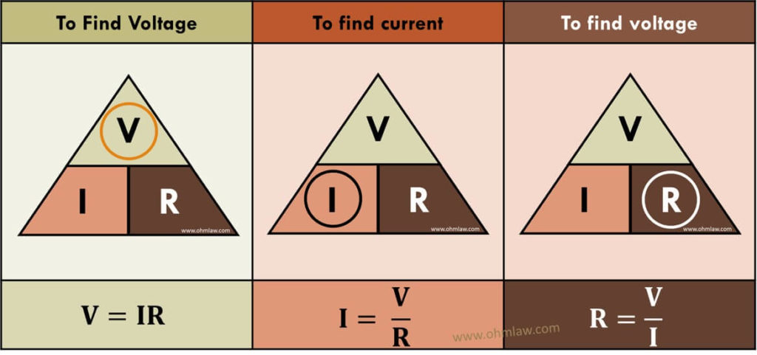

Above you can see the ohm’s law triangle. This law is crucial in electronics, though it cannot be used in every scenario, for basic circuits like these it is quite useful to get an idea of what you’re working with. The letter right next to each other on the triangle get multiplied while the letters above and below each other get divided.

While this would be true using ideal LEDS, we must consider the fact that different colored LEDs have different forward voltages. Since I am using red LEDs, I measured the voltage across the diode with a multimeter and found that the voltage was 1.8V. This means that a voltage drop occurs of 1.8V, meaning that the minimum resistance is closer to 400 ohms, not 491.5ohms. I decided to use a 750ohm resistor, making the current 10.7mA flowing through each LED. Another important factor to consider is the power rating of the resistors being used. Using the formula P=VI, we can calculate the amount of power being used by the circuit. Seeing as the current is 10.7mA with a 750-ohm resistor and the voltage is 8.03V after the drop, we can calculate the power P=8.03V*10.7mA=0.0859W of power for the LED. Using a 1/4-watt resistor would suffice, although using a 0.5-watt resistor wouldn’t hurt and its generally better to use a wattage rating that is a reasonable amount above the power consumption.

I originally had 510ohm resistors when building the breadboard prototype, but after seeing how bright the LEDs were and the fact that they were a little hot to the touch, I decided to bump up the resistance. The fact that the resistors were hot makes sense because the power for the LED was at 0.126W and the resistors only had a wattage rating of 0.25 (1/4) watt.

Luckily resistors and LEDS are cheap so any vendor with the size and color you need is fine so long as you know the maximum current rating of the LEDS and the wattage and size of the resistor. Breadboards are also another important component needed for this project, to build the prototype and see how you the sign would look physically. The size and spacing of the components will be very important when designing the PCB. I have created an BOM of the parts that I used to make my name spelled out using red LEDs which is linked under “BOM” in the project directory. This BOM also includes what you would need if you wanted to make a PCB of your LED sign art. There are more expensive versions of these components, but if you’re just starting out you don’t need the most expensive equipment.

**Part 2: Designing the circuit on the breadboard:**

Once you have everything you need to make the LED sign, it’s time to start prototyping the circuit on the breadboard. It’s important to keep in mind that since we are working with real world components and not ideal ones that the forward voltage across the LEDs that you use will vary to a slight degree. Even when buying a pack of LEDs from a vendor each LED will have slightly varying characteristics. This means that when using a current limiting resistor, the LED with the smallest forward voltage will always be activated first.

In the case of designing the circuit, this would mean that only three LED’s can be used per resistor in the circuit, 4 or more will result in only the first 3 LEDs turning on, which can be seen in the picture below.

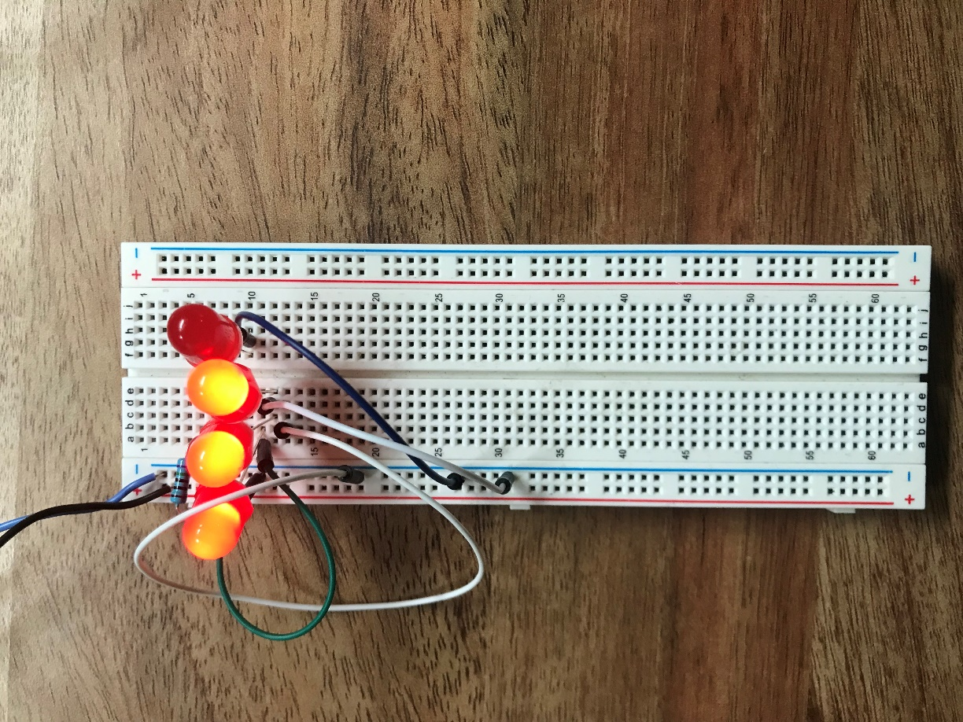

A simplistic way to design this circuit would be to have a resistor with a set of 3 LEDS in series and one resistor per column so that the entire circuit is in parallel. By creating a parallel circuit, the current flowing through each resistor (all which have 750ohm resistance) should theoretically be the same. However, there will be slight differences in current, depending on the wire length and the distance it needs to travel to reach the LED, but this difference should be low. There are better ways to design this circuit and reduce power consumption (such as an LED driver), however I wanted to keep this project relatively simple and beginner friendly. My other project involving a sign that displays the word “LOVE”, is a more complex version splitting the power in half between two separate LED drivers, which can be found on my Github page at github.com/DRTech98.

The drawing below represents the schematic needed to create an LED sign. Note that I represents the current flow and V represents voltage, with the polarity of each LED and the battery shown along with a ground symbol at the end of the LEDs to complete the circuit.

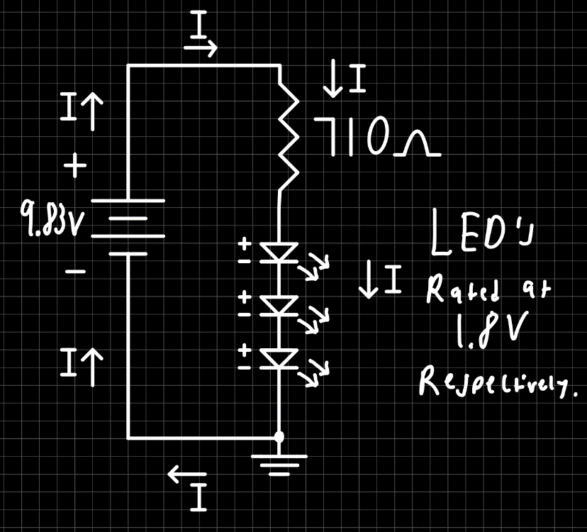

In terms of placing components on a breadboard is important to know which rows or columns conduct so that there is proper current flow and voltage output. The picture below shows which rows and columns are connected.

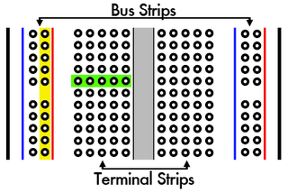

The blue and red vertical lines represent voltage rails (bus strips) which can be used as the power supply of your circuit (red is positive, blue is negative). The green horizontal line represents the terminal strips and where components should be placed for them to be considered electrically connected. An easy way to build our circuit would be to place the wall wart power supply on the voltage rails. Then placing the starting end of the resistor close to the positive rail with a jumper wire and the end of the resistor on the terminal strips (note the direction of the resistor and its placement does not matter). Then place the anode (positive long leg) of the LED on the same row terminal strip as the end of the resistor and the cathode (negative short leg) on another row of the terminal strip. The cathode should then be connected to the negative voltage rail so that the circuit is properly grounded. The picture below shows a representation of an LED in a schematic and 3D perspective.

Making a parallel circuit on a breadboard is usually a straightforward concept however, in the case of creating letters using LEDs it can be challenging. Designing the circuit in series isn’t the best idea seeing as while the current will be consistent the voltage across the LEDs will start to vary, and while current in parallel circuits usually differs, since we are using the same resistance throughout the current should be relatively consistent for each column. To make a resistor or LED in parallel, both leads must be in the same row with each other while making them in series only requires one lead of each on the same row.

For this circuit it is essentially one resistor with 3 LEDs in series and the next column occurs until the sign is finished with all components in parallel with each other. The picture below shows a wiring diagram of one row of LEDs on a breadboard circuit with 9V power supply.

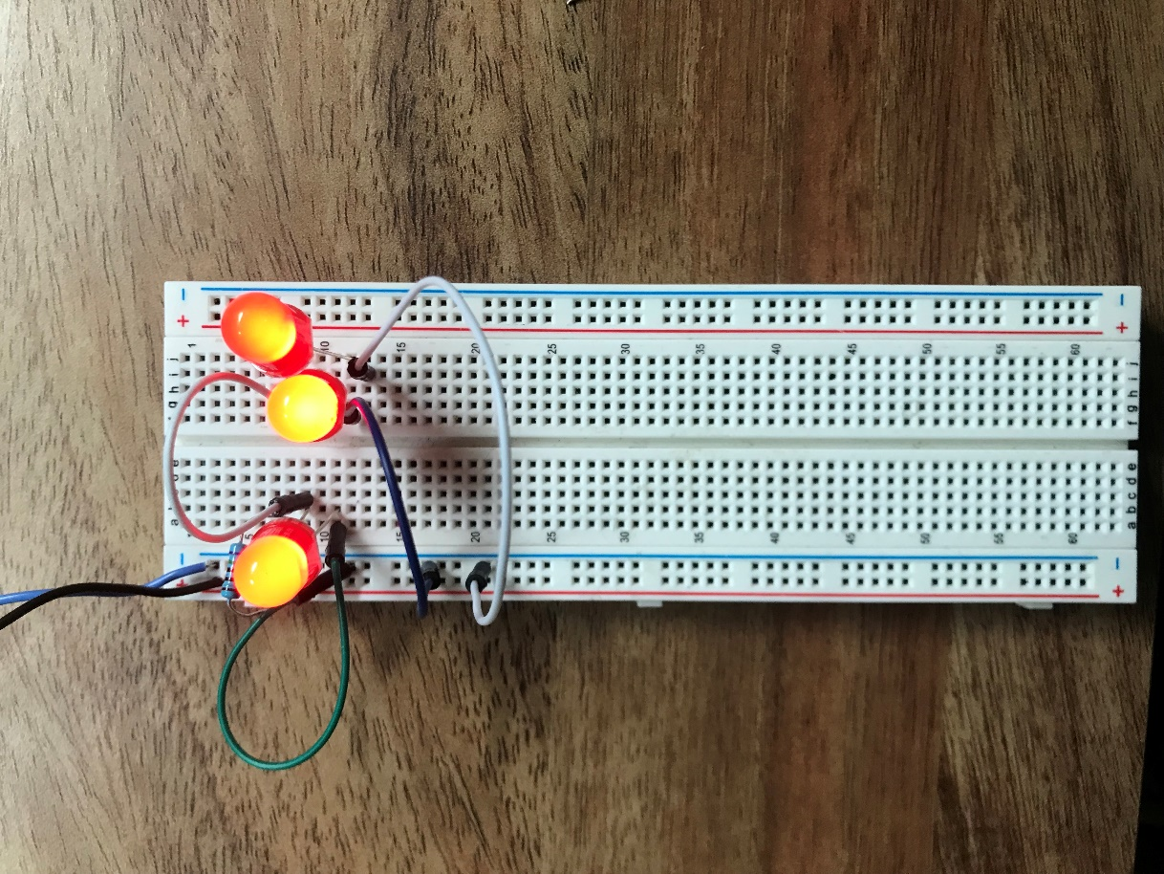

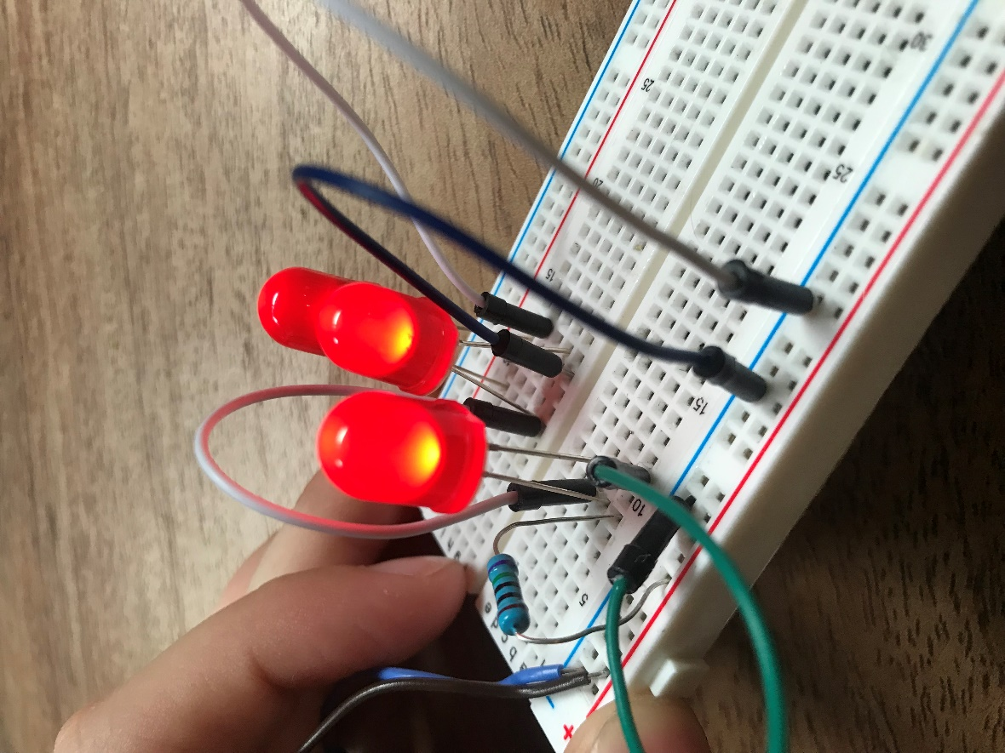

I attempted to see if I could make my name all in parallel but accomplishing on a breadboard is not possible, so I built the circuit in series to give you an idea of what your sign could look like. Keep in mind that certain LEDS are brighter than others because the LEDs are not in parallel with each other on the breadboard, and that the final project will look much cleaner.

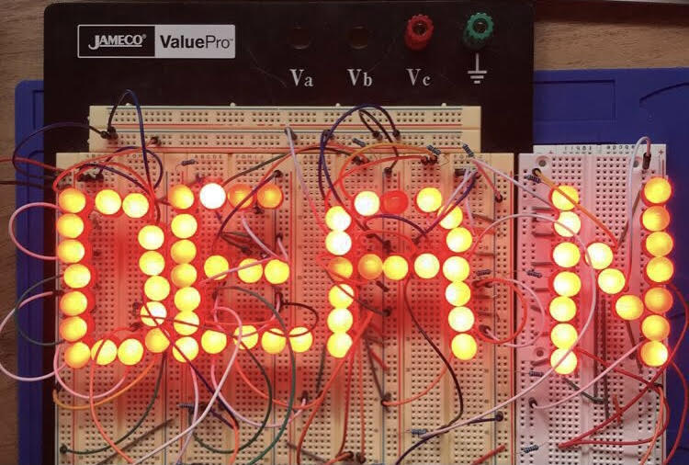

**Part 3: Designing the PCB:**

Once the breadboard prototype is finished, it’s time to take our circuit and recreate it to work on a PCB. Numerous different free software can be used to create your own PCB, however for this project I decided to use KiCAD seeing as it is one of my favorites in terms of its UI layout and simplicity. Links to download the software and buy the components I used can be found at the end of the project.

First let’s start by creating a new project; this is where the schematic and board layout editor will be kept along with the Gerber files used to get the PCBs manufactured. When creating a new project, we are placed in a blank schematic, free to choose where and what components we want to use for our circuit. After clicking file and new project and giving it a name, you will have two files in your project. There will be a schematic and KiCAD file under the project. Click on the schematic project to begin the new PCB.

Placing components can be done using the shortcut shift + A then clicking anywhere on the sheet. Once you click after pressing shift +A, a menu will appear allowing you to search for different components. In our case, we need resistors, LEDs, and a voltage source, which we will represent as a battery in the schematic. The pictures below show the menu for choosing different types of components and the icon to click to access the menu without using the shortcut.



Once the components are placed by simply clicking and placing the component on the schematic, using the w key draws a wire to connect our components. Note that the circles at the end of each component is where the wire runs to electrically connect them. The two pictures below show unconnected and connected components.

Referencing the schematic, we drew earlier; we need to connect the battery to the resistor with 3 LEDs in series and repeat that as many times as needed. For my sign I need 69 LEDs with 23 resistors (69/3=23, 3 LEDs per resistor) meaning that I will have 23 columns all in parallel with the voltage source. Mounting holes can be connected to ground as well, used to hang up the sign or attach it to a custom-built case. The picture below shows the schematic of our PCB.

Annotating the symbols by the Y position can be done to label each component in order from start to finish pressing the annotate symbols command and pressing annotate.



Then we can assign PCB footprints to each component using the assign pcb footprints menu to select what we need. Chose the proper footprint library and then click on the footprint that you want. I used 10mm through hole LEDs, DINO204 resistors (17.34mm in length) and solder wire pads for the battery. The size of the mounting holes can vary but I decided to stick with ones on the smaller side. When choosing components make sure that under footprint filters that “filter footprint list by library” is turned off so that you can chose the component you want. The next couple of pictures show the footprints that I decided to use for my project. Here are the exact text properties of the footprints that you can copy and paste into your schematic:

Battery Pads: Connector_Wire:SolderWire-0.75sqmm_1x02_P7mm_D1.25mm_OD3.5mm

Resistor: Resistor_THT:R_Axial_DIN0207_L6.3mm_D2.5mm_P10.16mm_Horizontal

LED: LED_THT:LED_D10.0mm

Mounting Hole: MountingHole:MountingHole_2.7mm



Once the schematic is finished and the Electrical Rules checker shows no warnings or errors, we can create a netlist to use for the board layout editor. The electrical rules checker is the icon of a ladybug and results in a menu displaying the total errors or warnings. The netlist icon displays “NET” in white capital letters.



Clicking on the file labeled kicad_pcb will display the board editor. Here we can upload the netlist and begin placing our components to our liking.



Starting with the LED’s is the easiest thing to do first, seeing as the pcb editor directly takes what’s from the schematic and interconnects all the components for you. All we must do is place our LEDs in such a way such that it spells out the letters we want to display on our sign. Using the shortcut M key, we can move components around and depending on the grid size will determine on how far that component moves. Try and keep the LEDs relatively the same spacing, as it will make the sign look neater and more professional. I generally stuck with a spacing of 1.3mm per LED and made sure to check the 3D viewer using the shortcut alt + 3 to get an idea of how the sign would look in person.



Traces will be used to electrically connect the components onto the PCB. Generally, stick with short and thick traces, and there are plenty of free online trace width calculators that tell you the width needed to carry the amount of current flow in the circuit. Avoiding traces that have right angles and look unaesthetically pleasing should be done as well, to make the overall appearance of the sign better. Our circuit does not use a lot of current nor power, however the only concern we should have is that some of the traces that connect to resistors from the power supply will be longer than others, so I decided to use a trace width of 0.5mm which should be more than enough to suffice. Once your components are placed, adding a graphic line in the edge cut layer will create the border of your PCB, and graphic arcs can be added to make round corners instead of having sharp edges.

In terms of layer stack up, this is a two-layer board with a front and back copper layer both consisting of GND planes. A power plane for this type of project is not necessary, we just need the copper fill to consist of the ground plane so that the entire circuit is connected to the same ground throughout. When creating the border and planes for the PCB I use a 1.000mm grid on the Edge Cuts Layer, seeing as it snaps and makes straight lines easily compared to the smaller or larger grid sizes.

Once the border is created, then by clicking on the “Add filled zones” icon we can create a two-layer board consisting of a GND (ground) plane on the front and bottom copper layer. Just make sure that all the components on your PCB are covered by the square along with the border so that a single ground plane can cover the entire PCB.

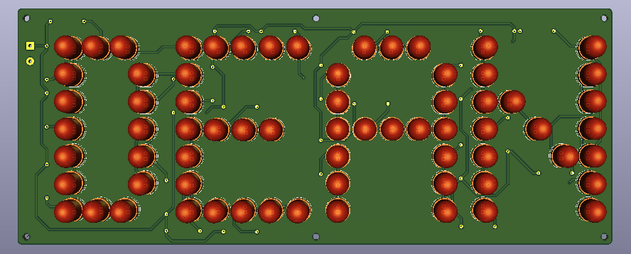

Once the PCB is done and the Design Rules Checker shows no errors or warnings, we can now create Gerber files to upload to JLCPCB. Using the plot command, we can create a Gerber folder relative to the project file path and generate drill files and plot files. The default settings are fine, just make sure to uncheck generate Gerber job files as those are not needed.



Plot Layout


Once the files are created place them into a zip file and upload them to JLCPCB. With the cheapest shipping selected (10-18 days), the PCB costs around $22.00 which is what I expected considering the dimensions that I was working with. Once the PCB comes in, we can then move on to the final step which is soldering the components on.

After 10-15 days, the PCBs came in the mail, and based on the results they look great! The next and final step however, remains with soldering the LEDs, resistors, and power supply into the square terminals on the left hand side of the board.

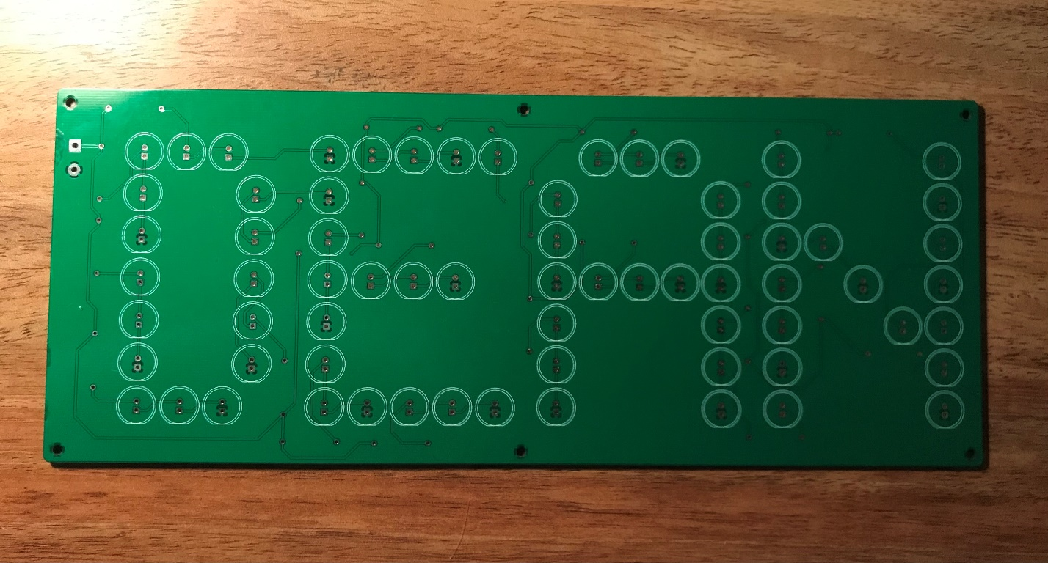

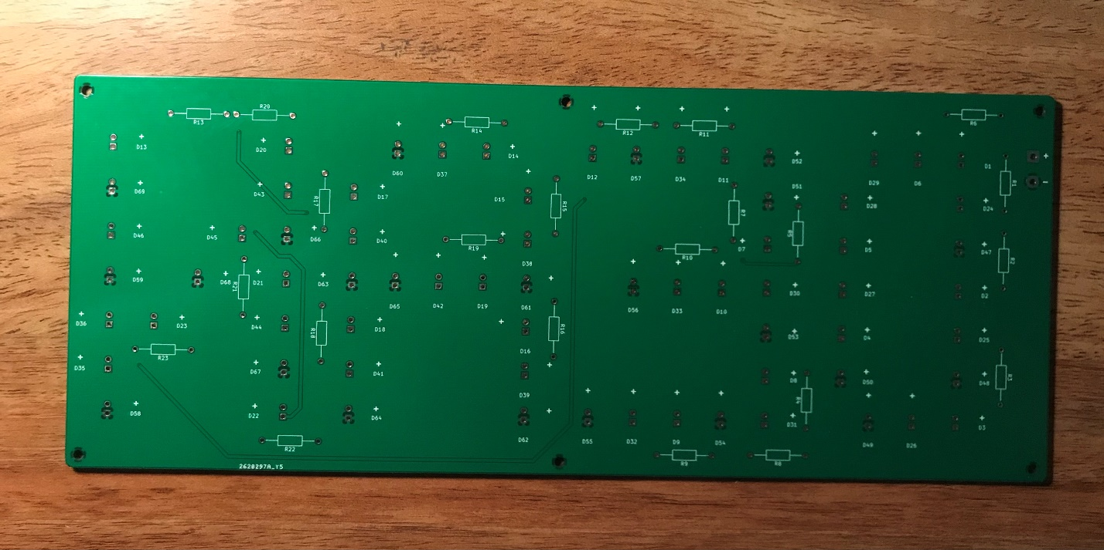

**Part 4: Soldering:**

Here comes the second hands-on part of the project. To solder the LEDs, resistors, and power supply on the breadboard, you’ll first need to use flux on the PCB. Flux essentially allows the solder to flow easier and joints will look cleaner as a result. For this I recommend using a flux pen, seeing as it’s not as messy and can last for a long time. To use it simply open the cap and rub the brush near the holes of the component to add liquid to the surface.

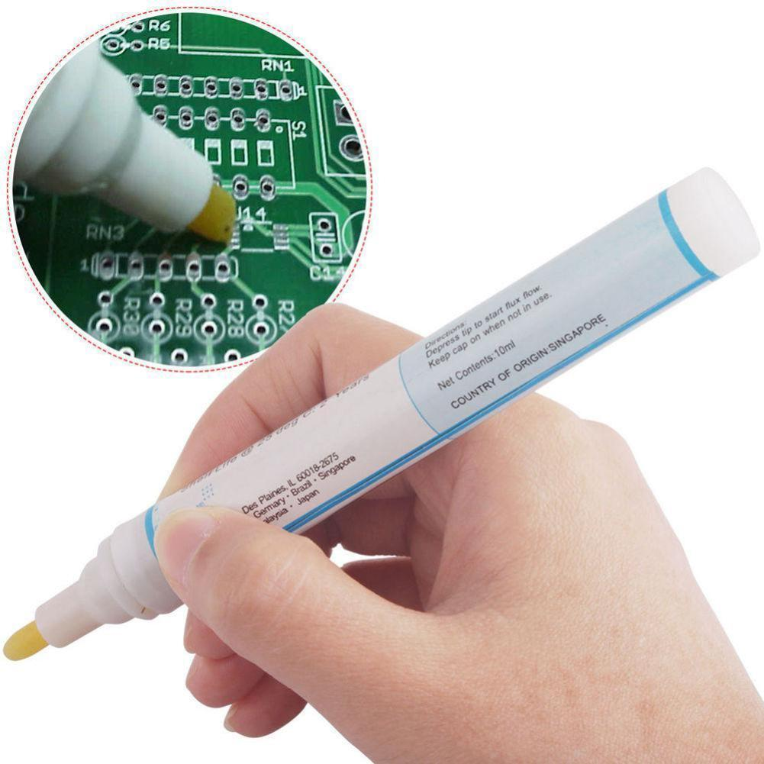

I used 0.8mm solder for each component on the board but 1.0mm solder will also work as well.

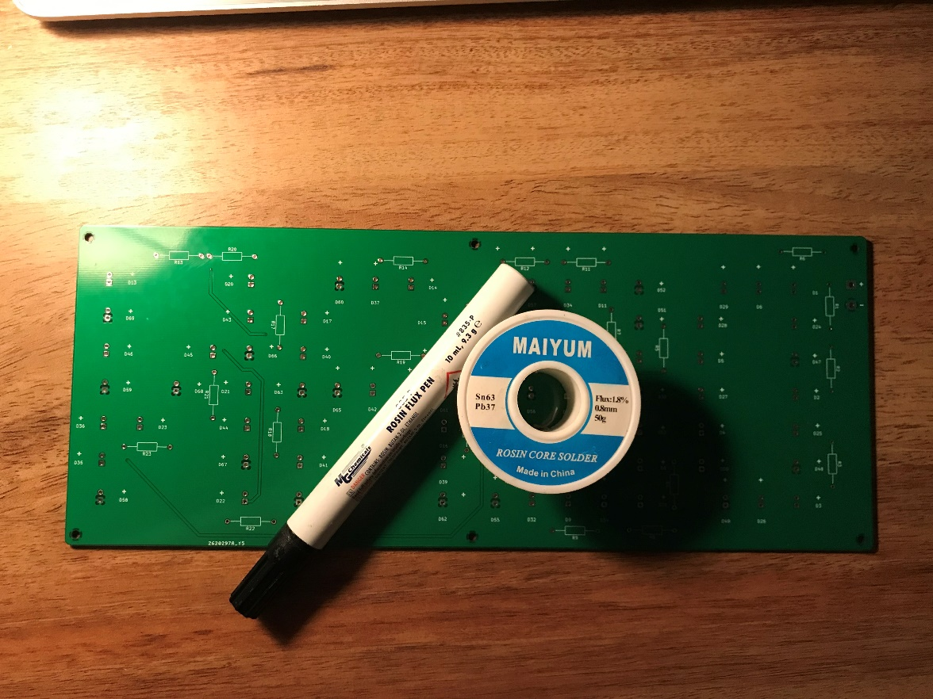

The type of tip on the soldering iron itself is also very important, seeing as the thicker tips are generally used for soldering on large components while the thinner ones are used more for microelectronic and surface mount work. I used a flat head tip, like that of a flat head screwdriver seeing as it does a good job of distributing heat and allows the solder to flow quickly. To start, first place the resistors on the back on the PCB where a square box with leads labeled “R#”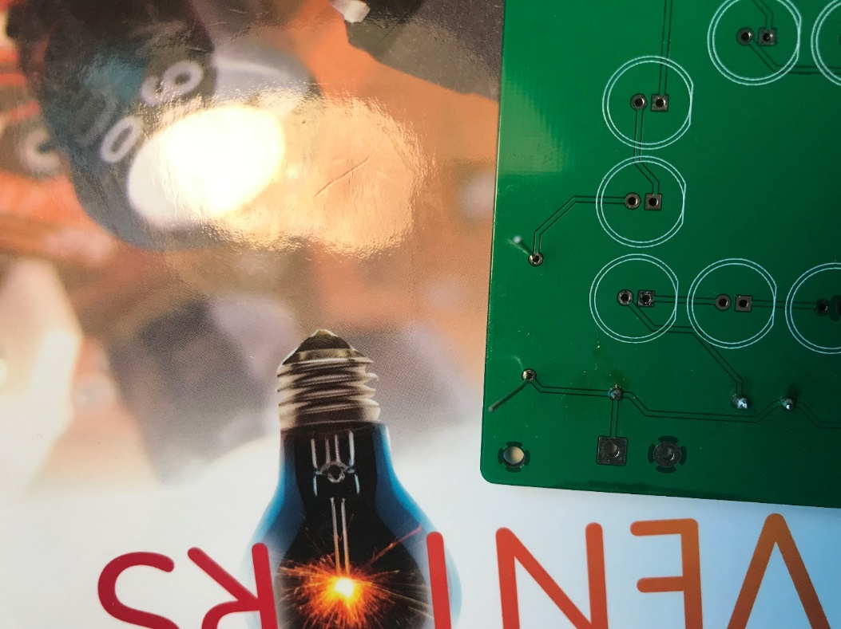

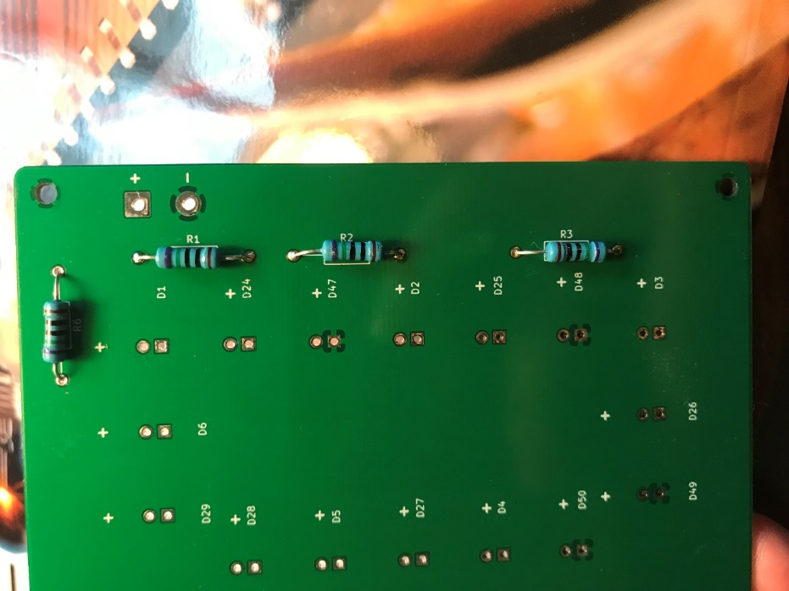

To solder a joint, place the tip of the iron between the pad and the lead, this will allow the soldering iron to meet both materials at once causing the solder to flow as soon as it touches the iron. Solder the joint until it fills up to the shape of a volcano, which then you can take the iron off and snip the leads with a plier.

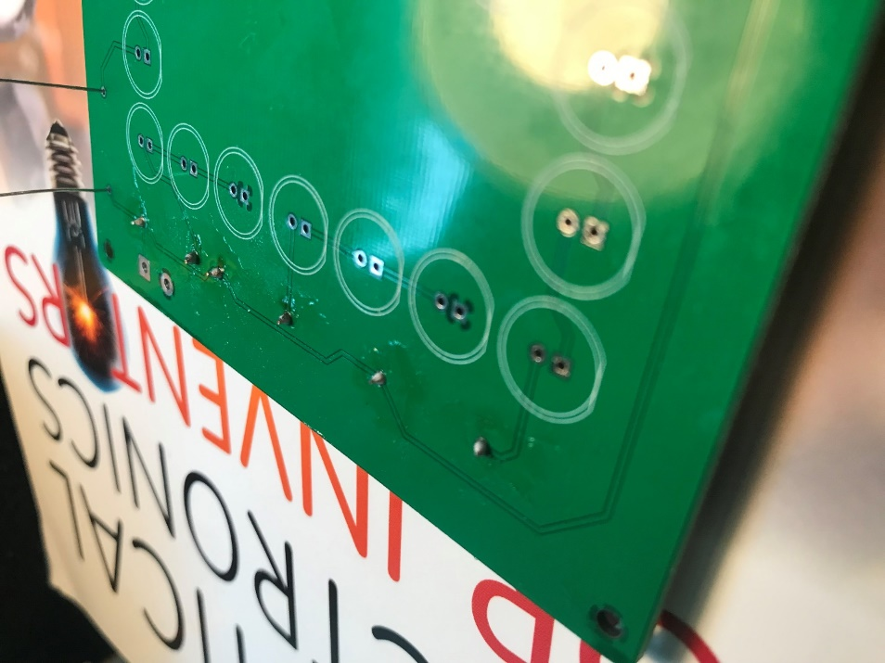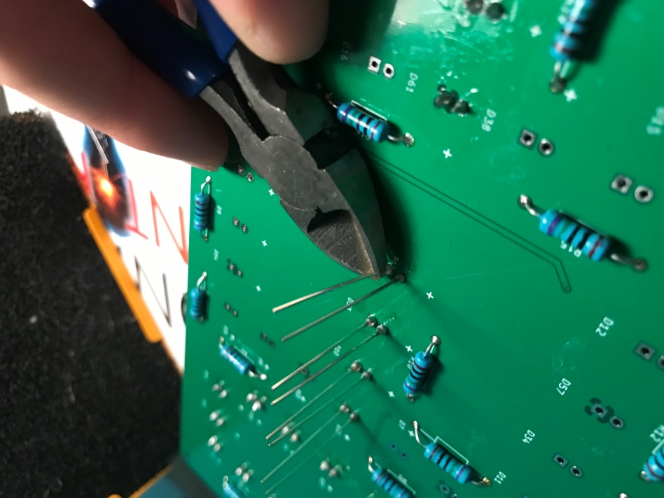

Make sure that the correct lead of the LEDs goes in their respective hole, otherwise the LED will not conduct and stay turned off even when the power supply is plugged in. The resistors on the other hand, can be placed in either direction or will still limit the current flow regardless. Clip the leads with a plier at the top of the volcano shaped solder joint as shown in the picture above. Repeat this step until all parts are soldered on.

**Part 5: The finished product:**

Once everything is soldered in place, plug in your sign, and see how it looks. You just created your own LED art! With our circuit design, all the LEDs should appear to be the same brightness. With the mounting holes, we can either hang up the sign with nails or make a custom 3D printed case, either or will suffice. Thanks for taking the time to look at my project!

